**HL Unit 5** **– Abstract Data Structures**  
Quiz 4 – Linked Lists

|  |  |  |  |
| --- | --- | --- | --- |
| **Question 1** | | | |
| Objectives: | 5.1.11 | Exam Reference: | May-17 9 |

Identify the components of a node in a doubly linked list. [3]

|  |  |  |  |
| --- | --- | --- | --- |
| **Question 2** | | | |
| Objectives: | 5.15.6, 5.1.11, 5.1.12, 5.1.13, 5.1.19 | Exam Reference: | Nov-16 11 |

1. The diagram shows a list of names held in a circular linked list. The end of the list is pointed

to by an external pointer, X.

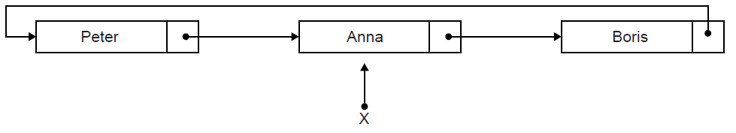

1. State the first name in this circular list. [1]

Two operations are performed on the list in the following order:  
 1. A node containing the name Sarah is inserted at the beginning of the list.  
 2. A node containing the name Ken is inserted at the end of the list.

1. Sketch a diagram showing the resulting circular linked list. [3]

1. Describe how the number of names held in this list could be determined. [4]

1. Explain how a stack could be used to output, in reverse order, all names held

in the linked list. [4]

1. Compare the use of static and dynamic data structures. [3]

All times are stored in the collection as the number of minutes since midnight. However, they  
 are displayed on the screen in 24-hour format (for example, 10:58 is stored in the collection  
 as 658).

1. Construct an algorithm to convert the times held in the collection into hours and

minutes needed for the 24-hour format displayed on the screen. [3]

If a plane arrived more than 30 minutes ago it is removed from the linked list and the next  
 one in the collection is added to the end of the list.

1. With the aid of a diagram, explain how a plane which arrived more than 30 minutes ago

could be removed from the linked list. [4]

1. For the application described above, compare the use of a linked list with the use of a

queue of objects. [5]